St. Mary the Virgin, Calverleigh

**‘RESTORE THE FLOOR’**

**Coffee Morning**



**Saturday 10th May**

**10.00am – 12 noon**

**@**

**Calverleigh village hall**

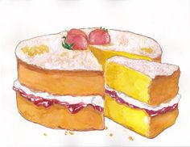

**Cake stall Draw**



**Competitions**

**Bring and buy Refreshments**

**All proceeds will go towards the church floor repair fund**